- Consider the grid-world given below and a robot who is trying to learn the optimal policy. If an action results in landing into one of the shaded states the corresponding reward is awarded during that transition. All shaded states are terminal states, i.e., the MDP terminate once arrived in a shaded state. The other states have the North, East, South, West actions available, which deterministically move the robot to the corresponding neighboring state (or have Robot stay in place if the action tries to move out of the grad). Assume the discount factor = 0.5 and the Q-learning rate _ = 0.5 for all calculations. Robot starts in state (1, 3).
(a) Find the optimal value function V* at the states (3,2), (1,2) and (1,3).
(b) The agent starts from the top left corner and you are given the following episodes from runs of the
agent through this grid-world. Each line in an Episode is a tuple containing (s; a; s’; r).
Using Q-Learning updates, what are the following Q-values after the above three episodes [10]
Q((3,2),N), Q((1,2),S), Q((2; 2);E)
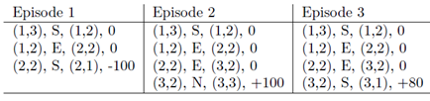
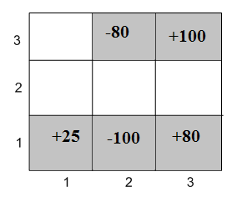
- Top down and bottom up weight matrices of a trained ART-1 network after presenting some input patterns are given as.
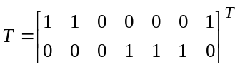and 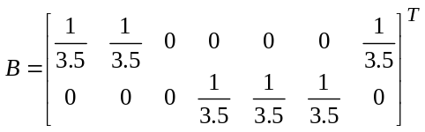
Determine the T and B matrices each time after presenting the following input patterns 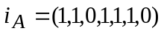 and 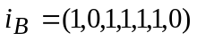. Assume vigilance parameter is 0.7. If we present 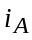 again to this network, which node will be the class of? [8]

